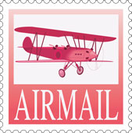
Create a Postcard
Insert an image for your destination in the top box. Use the lower box for writing your message.
Address here
Message here

